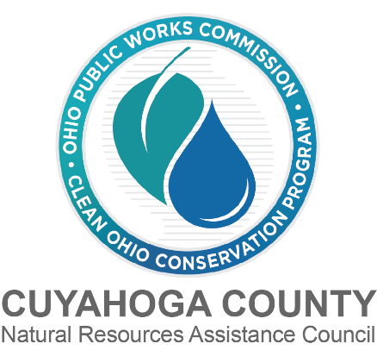

CUYAHOGA COUNTY COUNCIL RESOLUTION

The Clean Ohio Green Space Conservation program provides grants to preserve open spaces,
sensitive ecological areas, and stream corridors. The District One (Cuyahoga County) Natural Resources Assistance Council (NRAC), an eleven-member committee, is organized by the Ohio Revised Code to evaluate and recommend projects for Clean Ohio Conservation funds.

Fiscal Year 2027/Round 21 of the Clean Ohio Green Space Conservation application materials were made available Wednesday, March 18, 2026 and applications are due on June 19, 2026.

Ohio Statutes ORC 164.23(B) and 164.23(C) require that certain project applications include Resolutions of Support. If the applicant is a county, township, village or municipality and the project is located wholly within the applicant’s boundaries, then no resolutions are needed from any other local government. Park districts, regardless of the location of the property, are not required to obtain any resolutions but must consult with each county, township, and municipality in which the project is located.

All other applicants must obtain a county resolution for each county in which the project is located and from the impacted township, village, or municipality. If the project is in two to four townships, villages, or municipalities, then resolutions are needed from at least one-half of the impacted communities. If the project is in five or more communities, then resolutions are needed from at least three-fifths of the impacted communities. Resolutions of Support are due along with the application.

If your application requires a Resolution of Support from Cuyahoga County Council, please submit a completed Cuyahoga County Council Resolution of Support Request Form to Meghan Chaney at mchaney@cuyahogacounty.gov.

Resolutions of Support will be read into the record and then assigned to a Council Committee for further consideration and recommendation back to the full Council.1 A representative who is able
to answer questions about the application must be present at any Committee meeting as determined. Applicants will be notified of the date and time of these Committee meetings as they are scheduled.

In order to receive a resolution of support prior to the application due date the resolutions must be on the County Council’s agenda for the May 12, 2026, Council Meeting. Please fill out the attached request form and submit it to Meghan Chaney by Tuesday, April 21st, 2026, at 4:30PM.

1 Under the County Charter, resolutions are required to have three readings.
CUYAHOGA COUNTY COUNCIL
RESOLUTION OF SUPPORT REQUEST FORM

PROJECT NAME:

SPONSORING ORGANIZATION:

ADDRESS:

CONTACT PERSON:

PHONE:

EMAIL:

ESTIMATED PROJECT COST:

CLEAN OHIO GRANT REQUEST:

LOCATION OF PROJECT (provide a brief description below and attach a map):

COUNCIL DISTRICT(S) OF PROPOSED PROJECT LOCATION:

PRIMARY PROJECT GOALS:

SUBMIT THIS REQUEST FORM TO MEGHAN CHANEY at MCHANEY@CUYAHOGACOUNTY.GOV BY MONDAY, APRIL 20ST, 2026, AT 4:30PM.

District One Natural Resources Assistance Council (NRAC) |REQUEST FOR COUNTY COUNCIL RESOLUTION OF SUPPORT

